SCBI - ForestGEO 2023 Recensus Protocol

**Authors:** Iris Kennedy, Krystal Bagnaschi, Caroline Troy, Rachel Hoffman, Erin MacMonigle

The SCBI plot is 25.6 ha (400 m x 640 m) divided in 640 quadrats of 20 m x 20 m. An estimate of 25 quadrats, or 1 ha should be completed per week (an average of 5 quadrats per day). The goal of the recensus is to revisit and measure all tagged stems, and to tag and map new recruitments over 10 mm DBH (diameter at breast height).

Suggested workflow: 4 full days in the field, 1 half-day in the office to fix errors, conduct meetings, and discuss questions and problems.

# In the office:

1. Select quadrats to cover during the day. Use the plot map to guide you.
   1. Open Fieldmaps, connect to wifi, and delete the quadrats from the previous day
   2. Refresh fieldmaps and select the three dots to the right of the online map (for us it is titled recensus_march 29). Select download offline area, then zoom out and download the whole map. Click on the three dots to the right of the name and select rename. Name the offline map with the date and initials of team member(s) working on that iPad

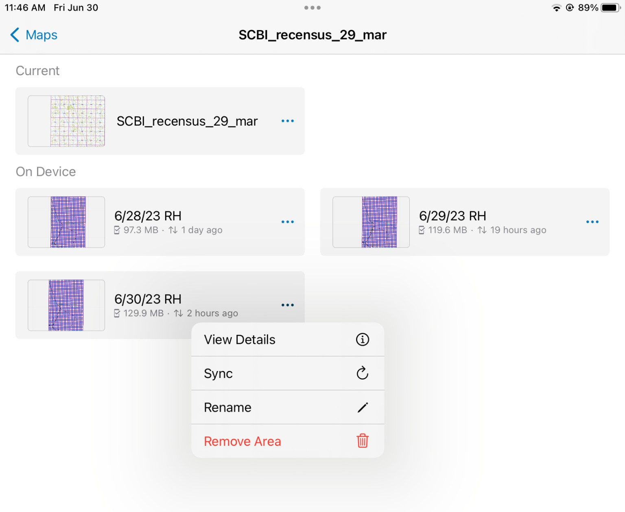

1. Verify complete set of instruments:
   1. iPad - check that charge is 100% and **turn wifi off in main settings** (not the pulldown menu)
   2. DBH tapes (5m or 10m)
   3. Compass
   4. 1.3 m poles
   5. Hammer, nails, wire, fishing line, trauma shears/wire cutters (colored wires for stems and fishing line for tags)
   6. New recruitment ID tags organized by column
   7. Write-on stem tags
   8. Replacement tags organized by column/quadrat
   9. Spray paint or lumber crayons
   10. Orange flagging
   11. Ladder (if measuring “Big Trees”, see section below)

# In the field:

When in the field, the first thing to do is to **check that the wifi is off.** Go to the general settings and ensure it is turned off.

We follow Condit (1998) protocols, which for a recensus can be summarized as follow:

1. Navigate to the selected quadrat. At SCBI, a **yellow rebar located in the SW corner** gives the quadrat name. For example, if the rebar tag says 6-12, it indicates you are in column 6, row 12. It will be read as quadrat 612 in the database or field form.

a. 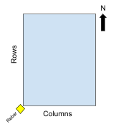

1. Locate the rebar and orient yourself. Locate trees within the quadrat. Local coordinates (x, y) are given in reference to a 20x20 m square.
2. If desired, set metric tapes around the quadrat perimeter. If the quadrat stem density is high, you can install tapes across the 10 m interval.
3. Survey quadrat beginning at rebar in SW corner, moving North. Continue East, as shown in figure below on the left. For more stem dense areas use the strategy on the right.

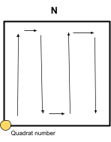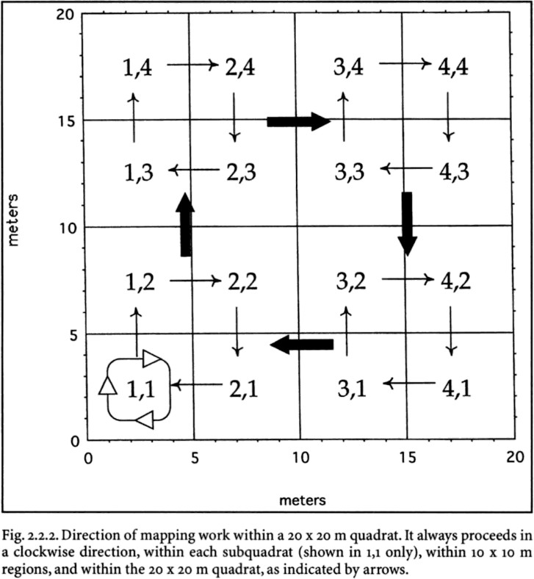

## TAGS:

* Each plant should have a metal tag with an ID number on it. The first 2 numbers on the tag indicate which column the plant is in.
* Placement: tags should be placed at the **base of the stem** to avoid loss of tag when the stem breaks *unless* you are in a boggy/wet area. In **wet areas** put the tag higher in the stem to avoid it being swallowed by swampy ground.

## MEASURING STEMS:

* Locate a stem and use the 1.3 m pole to measure the DBH (Diameter at Breast Height).
  + “**Breast-height is always calculated on the uphill side**” (see figure below) from (Condit et al. 1998). This is true for all trees *unless* they are leaning at an angle of 45 degrees or greater (refer to Code L in the Codes section for more detail).

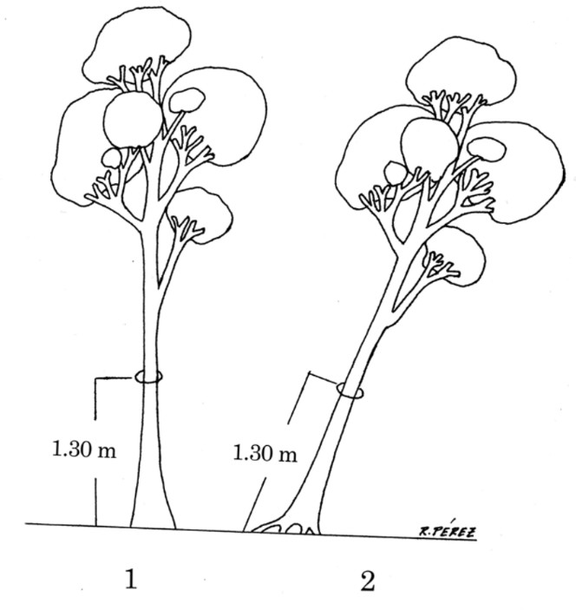

* + Calipers (for stems > 10 mm and < 40 mm): Place stem inside the lower jaws (flat part) of the calipers at the measured BH. Ensure that the calipers are perpendicular to the stem (particularly if the stem is not straight). Turn it around the BH until you find the point with the greatest diameter. Do not record decimals and *round down*. (Ex. A measurement of 21.7 mm is recorded as 21 mm).
  + DBH tape (for stems > 40 mm): Wrap the DBH tape around the tree and pull tight. Make sure the tape is not twisted or uneven on one side. Numbers should be facing up. Measurement is taken at the 0, and be sure to record in mm, not inches. DBH of 1,010 mm pictured below.
* If the trunk is irregular and prevents a representative measurement of stem diameter at

1.3 m, a different height of measure (HOM) may be necessary. If using an alternate HOM, use code A, and change the entry to the HOM field. If the entire accessible stem is irregular, and a different HOM does not resolve irregularity issues, use code I (e.g. in the Codes section).

* After each stem measurement is taken, mark the height of measure (HOM) with a lumber crayon or spray paint. Ideally the spray paint at BH will allow for consistency in where DBH is taken (but sometimes DBH must be corrected- see below) Re-mark/spray all recorded stems.
* When you find a stem that has been marked with spray paint from a previous census, DOUBLE CHECK that that is the correct height (make sure BH was measured from uphill, underside of lean, etc.) and then measure the DBH at that point (even if it is not

1.3 meters from the base of the plant). This maintains consistency. There may be instances where there are two spray paint lines visible. One of these will be the “corrected” BH.

## TAGGING AND RETAGGING TREES

* Use wire for all stems < 100mm DBH and nails and a hammer all stems > 100mm DBH
  + When a tree reaches 100 mm DBH, the tag is taken off the wire and nailed at eye level (usually around 1.8m height) into the northernmost side of the tree.

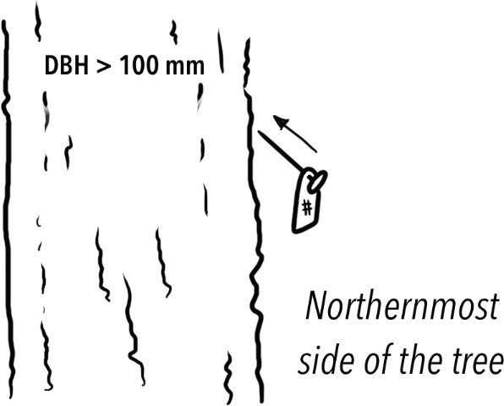

* When hammering in a tag, angle the nail down (see illustration above). This enables the stem to grow for a longer period of time without swallowing the nail.
* When replacing tags, NEVER pull a nail out. This will hurt the tree and likely cause a deformity. Instead, leave it in there and hammer in a new tag and nail.

When to remove tags:

* *For plants with single stems*: Leave tags on stems that are dead standing or dead and down. If the stem has completely disintegrated, and only the tag is found, remove it from the field.
* *For plants with multiple stems*: If the stem with the tag is dead, move the tag to the next living stem.

## MULTIPLE STEMS:

* “Separate stems which are obviously connected to one another below breast height, either above or below ground, are considered part of the same individual” (Condit et al. 1998).
  + Some tree species can produce new stems from exposed roots. If a shoot of the same species sprouts from a root that is visibly connected to another tree, that

shoot is considered a multiple stem. These shoots are often observed in American Beech (*Fagus grandifolia*) trees within the SCBI plot.

CURRENT 2023 Multiple Stem System

If a plant has more than one stem at BH, it is considered a multi-stemmed plant. Each individual stem that has a DBH > 10 mm needs to be measured and tagged. The stem with the largest DBH will receive Stem Tag 1.

*\*\*****NOTE****: columns 1-11, have colored wire system used, later columns and southern half (rows 1-10) will have only fishing line with a write on tag stating the stem number*

Wire system:

1. **Yellow wire with ID tag** - First largest stem (principle stem)
2. **White Wire** - attach metal write-on **stem tag 2**
3. **Blue Wire** - (sometimes black in past) attach write-on **stem tag 3**
4. **Red Wire** - attach write-on **stem tag 4**
5. **Green wire** - attach write-on **stem tag 5**
6. **Fishing line (clear, yellow, or red)** + write-on stem tag for stems 6,7,8…infinity

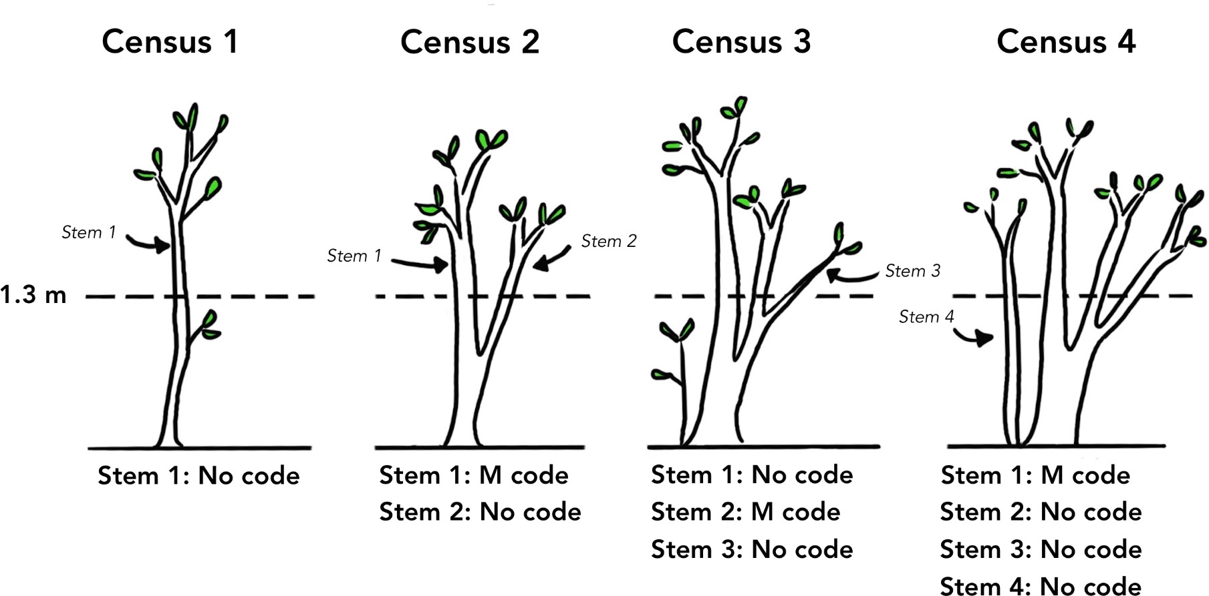

Adding the code MULTIPLE *(also refer to code table below)*:

* Code M is applied to a stem that has produced a new measurable stem between the prior census and the current census.

Clonal Species

* For clonal shrub species, e.g. *Asimina triloba* (Pawpaw), *Elaeagnus umbellata* (Autumn Olive), *Fagus grandifolia* (American beech) and *Lindera benzoin* (Spicebush) - if the base of the stem is **within 0.25 m** of a previously tagged stem, it is added to that individual as a new stem following the protocol above (stem 1 will receive the M code).

Prior Wire Color System

*Note: this system was used prior to 2023. It is included in our protocol in case you run across a double wire and need to understand what it means.*

During the 2013 re-census, colored wires were attached to up to 5 stems in each individual. The largest stem was given the tag. If the stem with the tag died, then it was moved to the next largest living stem.

1. **Tree tag with any wire color** – First largest stem
2. **White** – Second largest stem
3. **Blue or Black** – Third largest stem
4. **Red** – Fourth largest stem
5. **Green** – Fifth largest stem

*Example*: Stem 2 (White) is dead and wire is removed, Stem 3 (Blue) is alive, and Stem 4 is a new stem (no wire). Stem 4 should be given a *RED* wire following the color code protocol.

Under this system, if a stem was dead at BH, the colored wire was removed. However, the goal was to have five living stems tagged for each plant. If all the colors had been used in a previous census, but there were less than 5 tagged stems due to wire removal from dead stems, then you would restart the color wire protocol using two of the same color wire. Stem 6 would be double white, Stem 7 would be double blue, Stem 8 would be double red, etc.

*Example:* Spicebush in a previous census had 4 living stems (the stem with tag, White, Blue, Red), but in the current census Stems 2 and 4 are dead and there are two new stems. First, remove White and Red wire from the dead stems. Then use GREEN wire on Stem 5, and DOUBLE WHITE wire on Stem 6. *Remember,* double wires follow the existing color progression (white, blue, red, green).

## RECRUITS

## Recruit tags are organized by column in boxes, and within those boxes are organized sequentially from lowest to highest tag. Start with the lowest tag.

## If you find a stem exceeding 10mm DBH it must be added as a recruit.

## Click the blue plus sign in the bottom right corner of field maps to add the new stem, quadrat and stem tag will all need to be filled in

## **Rules for recruits**:

* + Clonal Species (astr, libe, elum, fagr)
    - For clonal shrub species, e.g. *Asimina triloba* (Pawpaw), *Elaeagnus umbellata* (Autumn Olive), *Fagus grandifolia* (American beech) and *Lindera benzoin* (Spicebush) - if the base of the stem is **within 0.25 m** of a previously tagged stem, it is added to that individual as a new stem following the protocol above (stem 1 will receive the M code).

## Non-clonal species: use a **radius of .5m**, if a new stem is *less than* .5m away from the principal stem it gets added to that individual as a new stem, if it is *more than* .5m away from the principal stem it gets added as a new recruit.

## BIG TREES

See “BT” in Codes section

* A “Big Tree” is a tree where you need to measure well above 1.3 m (usually 2m above

1.3 meters) to get an accurate DBH. A common example of this in other ForestGEO plots is trees with large buttresses (see image from Condit below). More often in the SCBI plot, Big Trees occur when two large stems grow together, resulting in tissue that has a different growth behavior than the main trunk.

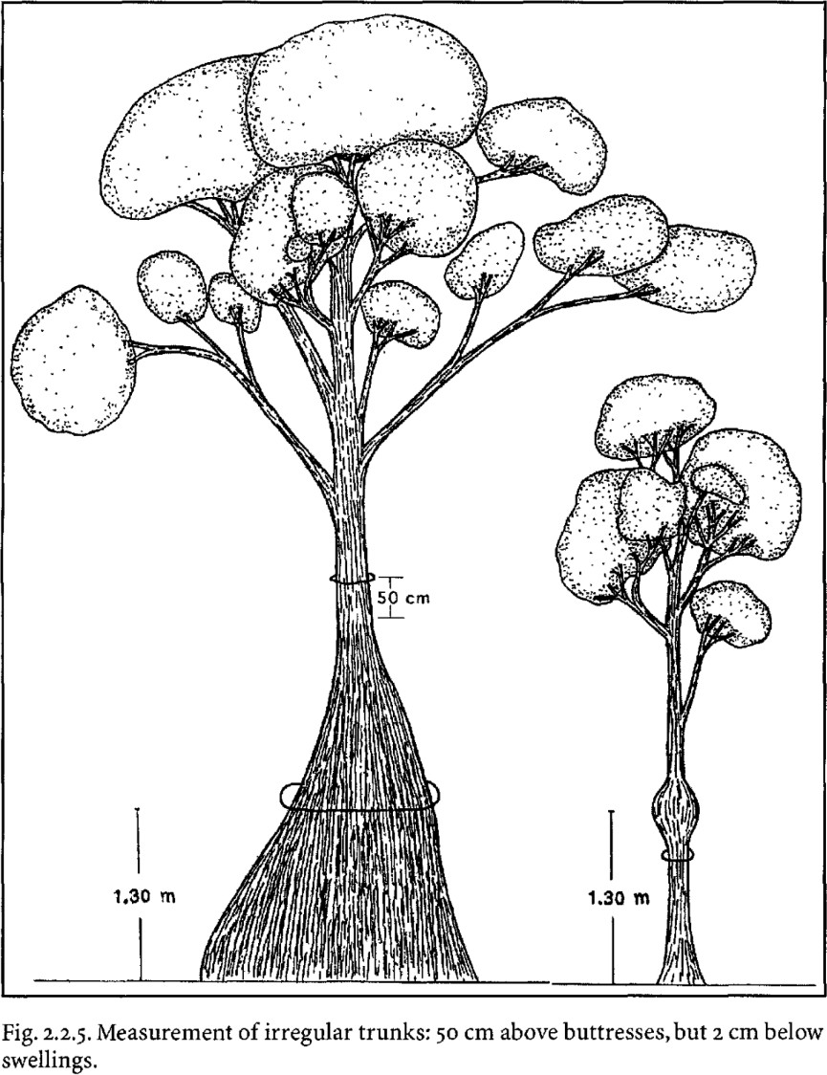

* Protocol for Big Trees

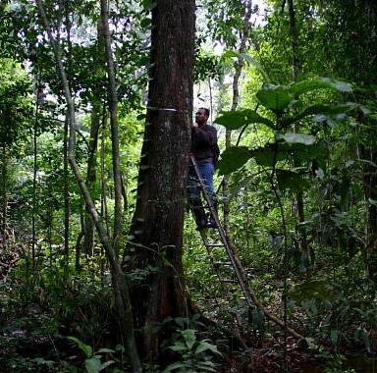

* + Select Big Tree (BT) as under the Codes section. Later, return to the tree with a ladder and lean the ladder against the tree. Measure 1 meter above the buttress or unusual tissue.

## RESPROUTS

See “R” in Codes section

* Sometimes, the measurable stems of a plant will die, but the plant itself is not dead. Instead, you may see epicormic growth on one of its stems, or small shoots emerging from the base of the plant. If this growth is too small to be measured, it is referred to as a Resprout (R).
* If this growth is > 10 mm at 1.3 m, it is no longer considered a resprout. Instead, add it to the plant as a new stem and give the plant code M.
* **In the field:** if a stem is dead standing but there is a clear resprout visible, move the tree id tag from the dead stem to the resprout and write in the notes “id tag on largest resprout”

## REPLACING TAGS (Code RT)

## STATUS

**The status of a stem is defined at Breast Height**. Remember to use a hammer to scratch the bark of a stem at breast height and the base to ensure it is dead.

|  |  |
| --- | --- |
| **Status** | **Explanation** |
| Living | The stem is alive at BH |
| Dead Standing | Stem is dead at BH, but still standing |
| Dead and down | There is no living or dead stem at BH (i.e., broken below 1.3 m) |
| Not Found | Neither stem nor tag can be found |
| Only tag found | Only the tag is found in the field, no plant material |

## CODES

In the app, code options will appear to the user as the code - full description (eg. A - alternate HOM)

|  |  |  |
| --- | --- | --- |
| **Code** | **Definition** | **Further explanation** |
| CL | clear list | Selecting this code takes the other codes off the list, sort of like a delete all. If a form has been submitted with codes, deleting them without using this code will not remove them from the data. |
| A | alternate HOM | If a stem is highly irregular at 1.3 m, an alternate height of measure can be used to take a more representative DBH. Take the measurement at the nearest regular part of the stem and record the changed HOM in the app. |
| B | broken above 1.3 m | Code applied to single stem trees when the principal/largest stem of the plant is broken above BH, whether living or dead.  For multistem species, code applied to each stem significantly broken above BH. |

|  |  |  |
| --- | --- | --- |
|  |  |  |
| C | dead above 1.3 m | Code applied when the majority of the principal/largest stem is dead above 1.3 m (See illustration) |

|  |  |  |
| --- | --- | --- |
|  |  |  |
| G | ID to Genus certain, species uncertain | If a tree cannot be identified to the species level, but can to Genus, this code can be used |
| I | stem irregular where measured | If the entire accessible stem is irregular, and a different HOM does not resolve irregularity issues, use code I to indicate that DBH may not be representative due to stem irregularities |
| L | stem leaning | Code applied when the stem is leaning at 45o or greater. Breast height is always calculated from the underside of the leaning tree (see figure) (from Condit et al. 1998).  Do not use this code for *Lindera benzoin* or other species for which leaning is typical*.* |

|  |  |  |
| --- | --- | --- |
|  |  |  |
| M | multiple stems | Code M is applied to a stem that has produced a new measurable stem between the prior census and the current census.  If a new stem comes from the ground and is less than .25 m from the principal stem, then code M is applied to the principal stem. If it comes from the secondary stem, the secondary stem receives the code M. If the main stem is **dead** and there is another stem coming from the ground (>= 10mm DBH,<0.25 m distance from first stem) the main stem still receives code M (not R!). |
| P | stem prostrate - parallel to the ground/on the ground | Code applied for *living* stems that are parallel to the ground or lying on the ground. |
| RT | replace tag | Code used if a plant is already in the database from a prior census, but is missing its tag and no replacement has been made yet. |
| R | stem dead; living reprouts or epicormic branches below 1.3m | Resprout codes are only to be used when the resprouts or epicormic branches are too small (< 1.3 m tall and/or < 10 mm in DBH) to be measured. Resprout is a code that applies to the *whole* plant, not the individual stem. If the "resprouted" part does qualify as a measurable stem, don't give it code R. Instead, it is classified as a new stem. If sprouting from the ground, resprouts should be within 0.25 m of the old stem. |

|  |  |  |
| --- | --- | --- |
|  |  |  |
| X | stem broken below 1.3m | Code applied when the stem is still standing, but has broken off at any point below BH. |
| DV | DBH verified | Sometimes you will receive an alert that the DBH has increased or decreased too much based on the data from the previous census. Code applied when you have double-checked that the DBH you entered is correct. |
| BT | Big Tree | Code is applied when trees have stems that have fused together or buttresses that would prevent a representative DBH from being taken at 1.3 meters. |

## GITHUB QA/QC ERRORS

Below is a table of some common errors to look out for and how to address them. It is always easier to prevent errors in the field as opposed to fixing them later. *Note: you can find a spreadsheet of the errors and their explanations in the Github repository, in the folder QAQC_reports titled “****GitHubAction_checks****”.*

Any errors that can’t be resolved by going through the iPad must be revisited in the forest.

|  |  |  |
| --- | --- | --- |
| **Error/Warning Name** | **Error/Warning** | **How to Fix/Address it** |
| duplicatedStemTags | error | Make sure no stem was recorded more than once |
| missedStem | error | Make sure no stems were missed in the quadrats already censused. To prevent this error, while in the field be very careful to make sure all secondary stems are measured/logged, especially when a plant is “Not Found.” |
| suspiciousNegativeGrowth | warning | Check for diameters that decrease too much, to prevent this in the field add code DV (dbh verified) if you have double checked that this measurement is correct |
| suspiciousPositiveGrowth | warning | Check for diameters that increase too much, to prevent this in the field add code DV (dbh verified) if you have double checked that this measurement is correct |
| CodeAButHOM1.3 | warning | Check for that Code A means a different POM than 1.30, if there is no alternate POM remove code A with CL (clear list) |
| missingDBH | error | Check that all DBH were measured, if not you will need to revisit the stem to measure it |
| unjustifiedZeroDBH | error | Check that dbh=0 is justified by X or C in codes |
| missingCrownPosition | error | Check that crown position was recorded if status is A, or DS |
| deadButNowAlive | warning | Check if tree was found alive after being recorded as dead, add code DV (dbh verified) if not already present |
| DCbutNowDS | error | Check that no down tree is back standing |
| missingPercentCrownIntact | error | Check that percent crown intact was recorded if status is A, AU or DS |
| missingPercentCrownLiving | error | Check that percent crown living was recorded if status is A, AU |
| DeadButCrownLivingNotZer o | error | Check that percent crown living is 0 if tree is dead |
| CrownLivingGreaterThanCr ownIntact | error | Check that percent crown living is smaller than percent crown intact |
| statusAbutUnhealthy | error | Check that status is AU when obvious signs of health issues. To fix, even if you see the status is listed as Alive currently switch it to AU to see if there is anything that comes up in the FAD fields that you can clear and then put the status back to A |
| missingFad | error | Check that if status is AU, DS or DC, there is a fad justifying it |
| missingWoundLevel | error | Check that there is a wound level when W in FAD |
| missingWinFad | error | Check that there is a W in FAD if a there is wound level |
| missingCankerLevel | error | Check that there is a canker_swelling_deformity level when K in FAD |
| missingKinFad | error | Check that there is a K in FAD if a there is canker_swelling_deformity level |

|  |  |  |
| --- | --- | --- |
| missingRotLevel | error | Check that there is a rot level when R in FAD |
| missingRinFad | error | Check that there is a R in FAD if a there is rot level, fix by selecting Rot from the FAD list |

COMMON STRINGS USED IN NOTES/COMMENTS

* **“tag removed”** – put for when you remove a tag from a plant. Tags should be removed from dead and down trees with *no remaining living stems or resprouts.*
* **“species is not __ is ___”** – put when you find a species that is mis-identified (the ___ are each a species code i.e. libe)
* **“wire removed”** – put for when you remove a wire from a stem. Wires should be removed from a stem that has been dead for 2 censuses, or if it is dead and down. (previously they used code WR for this). It is sometimes necessary for clarity to leave wires in the field to help future field crews deduce stems so it is sometimes a judgement call.